TASK 1

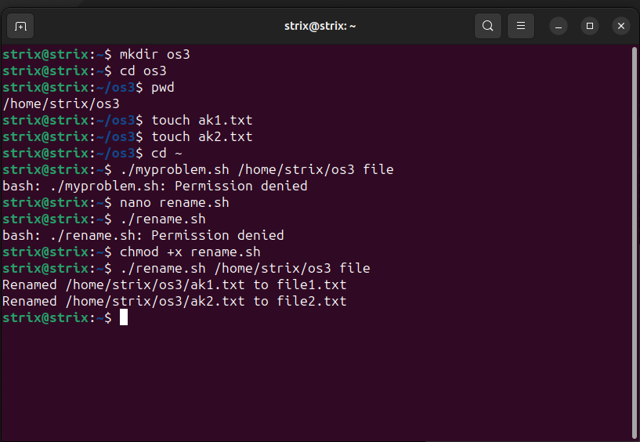



TASK 2

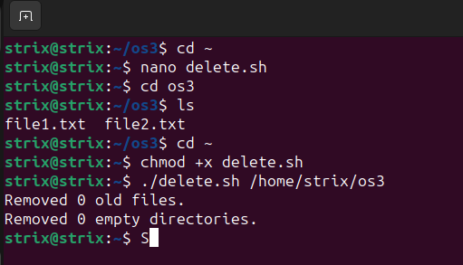

#!/bin/bash

# Check if the correct number of arguments are provided
if [ "$#" -ne 1 ]; then
echo "Usage: $0 <directory_path>"
exit 1
fi

# Extract the directory path from the argument
directory_path="$1"

# Check if the directory exists
if [ ! -d "$directory_path" ]; then
echo "Error: Directory $directory_path does not exist."
exit 1
fi

# Function to remove files older than a specified number of days
remove_old_files() {
local dir="$1"
local days="$2"

find "$dir" -type f -mtime +$days -exec rm {} \;
}

# Function to recursively remove empty directories
remove_empty_directories() {
local dir="$1"

find "$dir" -type d -empty -delete
}

days_threshold=7
remove_old_files "$directory_path" "$days_threshold"

# Count the number of files before and after deletion
before_files=$(find "$directory_path" -type f | wc -l)
after_files=$(find "$directory_path" -type f | wc -l)
removed_files=$((before_files - after_files))

echo "Removed $removed_files old files."

# Remove empty directories
remove_empty_directories "$directory_path"

# Count the number of directories before and after deletion
before_dirs=$(find "$directory_path" -type d | wc -l)
after_dirs=$(find "$directory_path" -type d | wc -l)
removed_dirs=$((before_dirs - after_dirs))

echo "Removed $removed_dirs empty directories."

TASK 3

#!/bin/bash

# Default time period (in seconds)
time_period=60

output_format="text"

collect_data() {
cpu_usage=$(top -bn1 | grep "Cpu(s)" | sed "s/.*, *\([0-9.]*\)%* id.*/\1/" | awk '{print 100 - $1}')
memory_usage=$(free -m | awk 'NR==2{printf "%.2f", $3*100/$2}')
disk_usage=$(df -h | awk '$NF=="/"{printf "%.2f", $5}')
network_traffic=$(sar -n DEV 1 1 | grep "Average:" | grep -v "IFACE" | awk '{sum += $5} END {printf "%.2f", sum}')
}

# Function to calculate average values
calculate_average() {
local time_period=$1
cpu_average=$(sar -u $time_period 1 | tail -n 1 | awk '{print 100 - $NF}')
memory_average=$(sar -r $time_period 1 | tail -n 1 | awk '{print $2}')
disk_average=$(sar -p -d $time_period 1 | tail -n 1 | awk '{print $NF}')
network_average=$(sar -n DEV $time_period 1 | grep "Average:" | grep -v "IFACE" | awk '{sum += $5} END {print sum}')
}

generate_report() {
echo "System Resource Report"
echo "----------------------"
echo "CPU Usage: ${cpu_usage}% (Average: ${cpu_average}%)"
echo "Memory Usage: ${memory_usage}% (Average: ${memory_average}%)"
echo "Disk Usage: ${disk_usage}% (Average: ${disk_average}%)"
echo "Network Traffic: ${network_traffic} KB/s (Average: ${network_average} KB/s)"
}

# Main function
main() {
collect_data
calculate_average $time_period
generate_report
}

# Parse command-line options
while getopts ":t:f:" opt; do
case $opt in
t)
time_period=$OPTARG
;;
f)
output_format=$OPTARG
;;
\?)
echo "Invalid option: -$OPTARG" >&2
;;
esac
done

main

